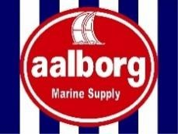
GOODS DELIVERY REPORT

GENERAL INFORMATION
Vessel: xxxxx
Delivery Date: March 26, 2026

Company Responsible for Delivery: Nitshore
Operation Location: Port / Barge

Operation Schedule
- Arrival at the port: 13:00
- Scheduled start time: 14:00
- Start of barge loading: 15:50
- Departure from the port: 16:48
- Arrival at the vessel: 17:16
- Start of onboard operations: 18:25
- Completion of the operation: 20:24

Photographic Record

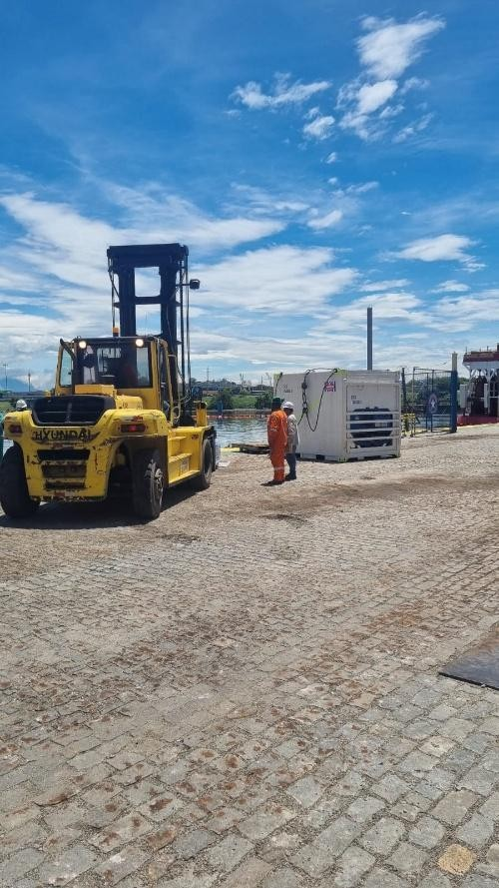

Transport Conditions
The goods were transferred to the barge, with refrigerated and frozen containers remaining powered throughout the entire transport using generators, ensuring the maintenance of the cold chain until delivery.

The transport was carried out in accordance with good practices for food handling and transportation, ensuring product integrity and safety.

Photographic Record – Transport
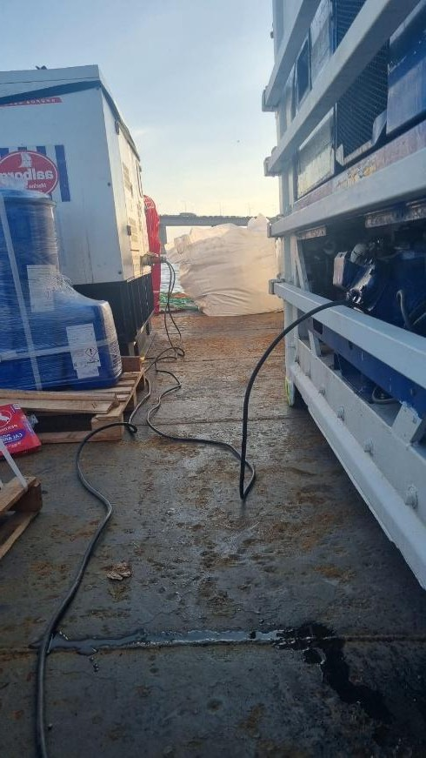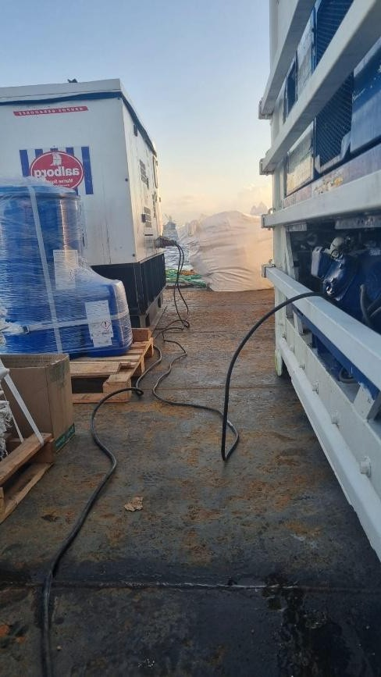

Temperature Control – During Transport
During transport, the following temperatures were recorded:

- Refrigerated container: 7.9°C
- Frozen container: -23.8°C

These values are within the recommended parameters for the preservation of perishable foods, in accordance with current sanitary regulations.

Photographic Record – Transport Temperatures
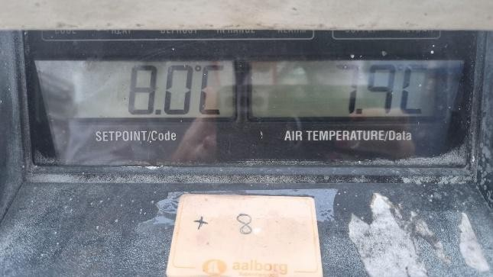
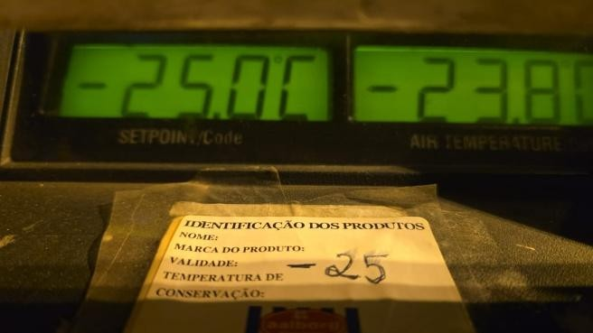

Temperature Control – At the Time of Delivery
At the time of opening and inspection onboard, the recorded temperatures were:

- Refrigerated container: 6.8°C
- Thermal box (refrigerated products): 5.8°C
- Frozen container: -18°C
- Thermal box (frozen products): -43°C

These records demonstrate that the cold chain was maintained throughout all stages of the operation, meeting food safety requirements.

Photographic Record – Delivery Temperatures
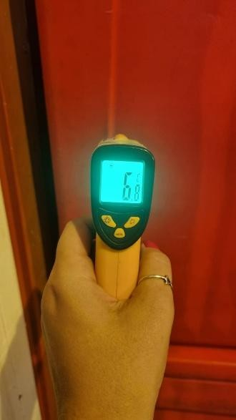
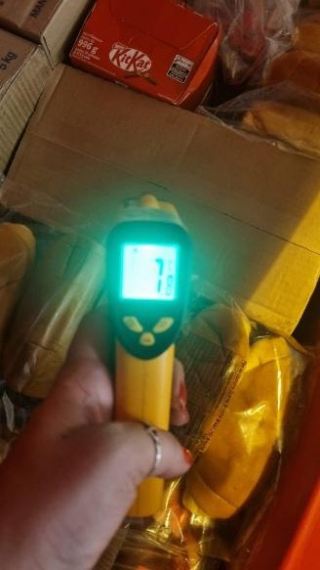
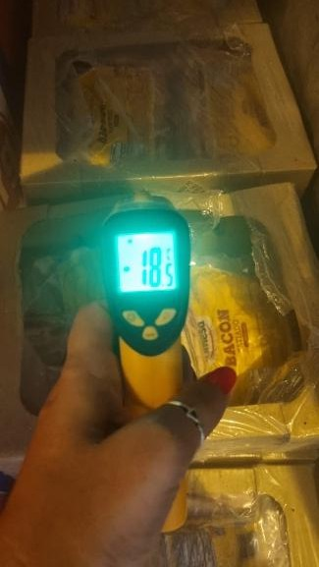
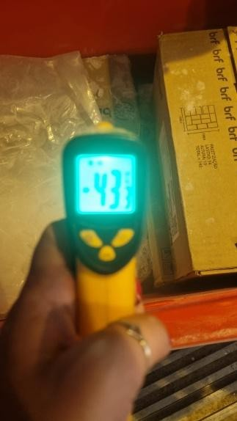

Product Quality Assessment at Delivery
During unloading, the goods were inspected, and it was possible to verify their integrity, quality, and hygienic-sanitary compliance.

Thermal conditions were maintained within recommended standards throughout the entire operation, and no non-conformities were identified.

Photographic Record – Product Quality at Delivery
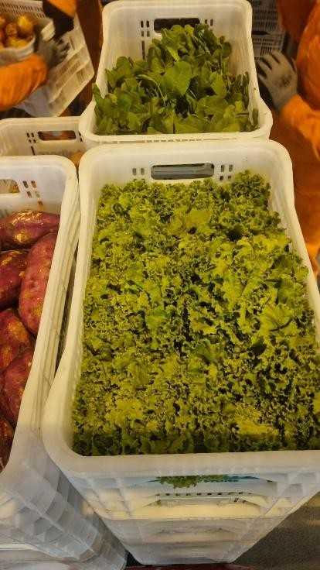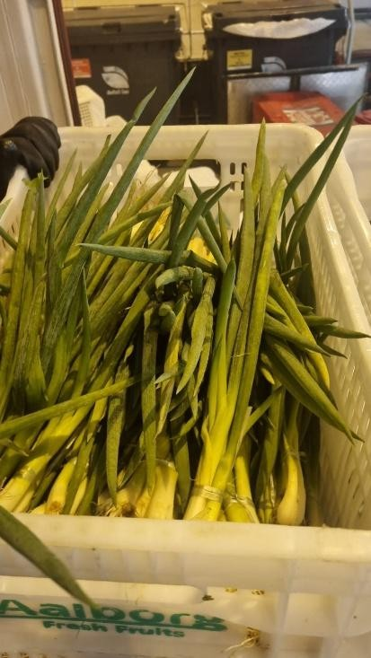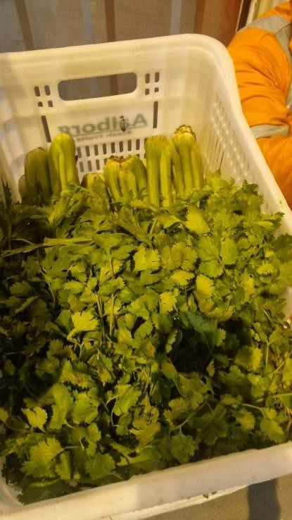
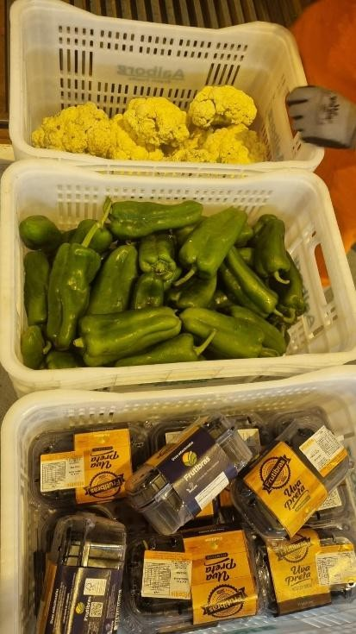
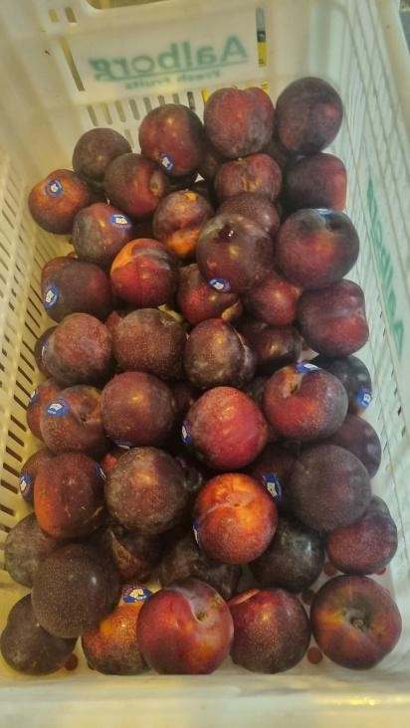
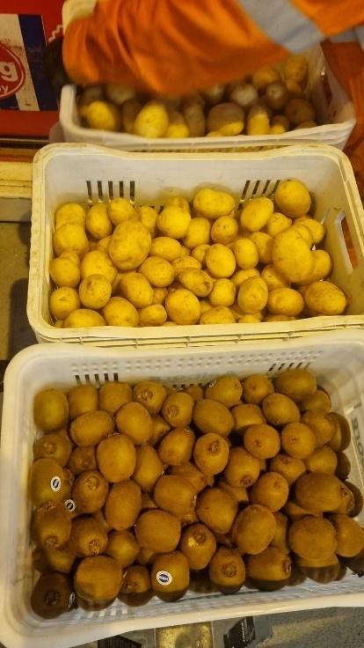
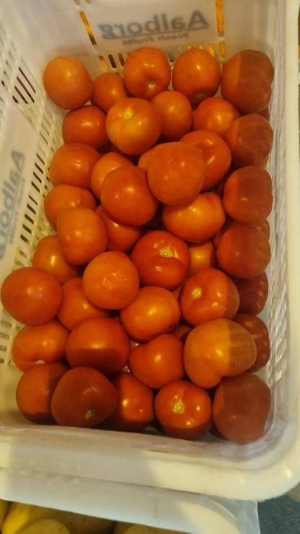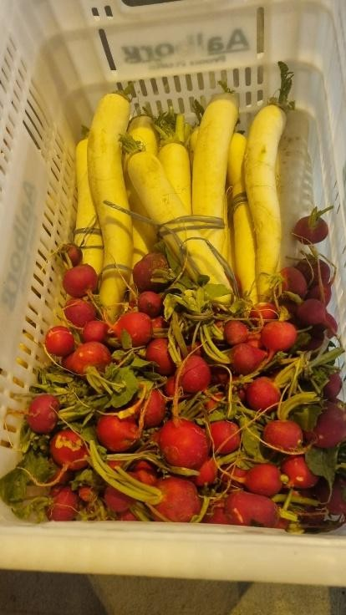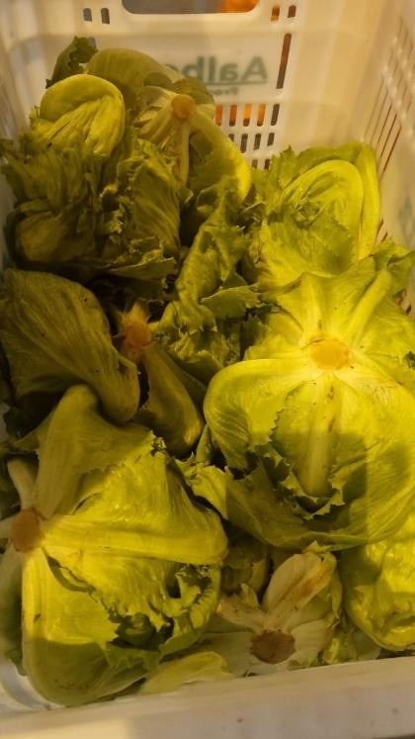

Final Remarks
The delivery operation was carried out satisfactorily, in compliance with standard operating procedures and good food handling practices, in accordance with applicable sanitary guidelines.

Throughout the entire process, the containers remained powered by generators, ensuring continuous temperature control and preservation of the cold chain.

The delivery was completed without any incidents, ensuring the safety, quality, and compliance of the products supplied to the vessel.

Report Prepared by:
Aline Semedo Nutritionist

